Data Structure and Algorithm
Laboratory Activity No. 13

Tree Algorithm

Submitted by: | Instructor:
Hermosura, Leigh B. | Engr. Maria Rizette H. Sayo

November 9, 2025

Objectives
Introduction
An abstract non-linear data type with a hierarchy-based structure is a tree. It is made up of links connecting nodes (where the data is kept). The root node of a tree data structure is where all other nodes and subtrees are connected to the root.

This laboratory activity aims to implement the principles and techniques in:
- To introduce Tree as Non-linear data structure
- To implement pre-order, in-order, and post-order of a binary tree
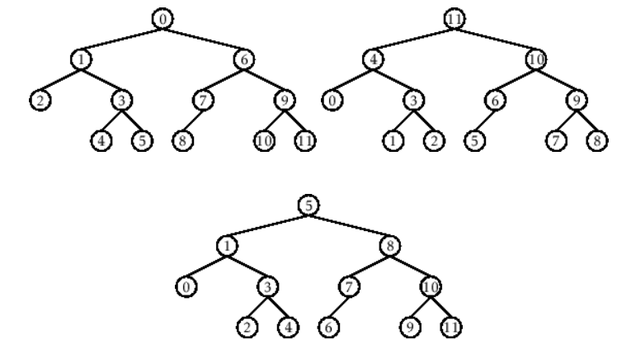

- Figure 1. Pre-order, In-order, and Post-order numberings of a binary tree

Methods
  - Copy and run the Python source codes.
  - If there is an algorithm error/s, debug the source codes.
  - Save these source codes to your GitHub.
  - Show the output

    - Tree Implementation

class TreeNode:
def __init__(self, value):
self.value = value
self.children = []

def add_child(self, child_node):
self.children.append(child_node)

def remove_child(self, child_node):
self.children = [child for child in self.children if child != child_node]

def traverse(self):
nodes = [self]
while nodes:
current_node = nodes.pop()
print(current_node.value)
nodes.extend(current_node.children)

def __str__(self, level=0):
ret = " " * level + str(self.value) + "\n"
for child in self.children:
ret += child.__str__(level + 1)
return ret

# Create a tree
root = TreeNode("Root")
child1 = TreeNode("Child 1")
child2 = TreeNode("Child 2")
grandchild1 = TreeNode("Grandchild 1")
grandchild2 = TreeNode("Grandchild 2")

root.add_child(child1)
root.add_child(child2)
child1.add_child(grandchild1)
child2.add_child(grandchild2)

print("Tree structure:")
print(root)

print("\nTraversal:")
root.traverse()

Questions:
- When would you prefer DFS over BFS and vice versa?
- What is the space complexity difference between DFS and BFS?
- How does the traversal order differ between DFS and BFS?
- When does DFS recursive fail compared to DFS iterative?

Results
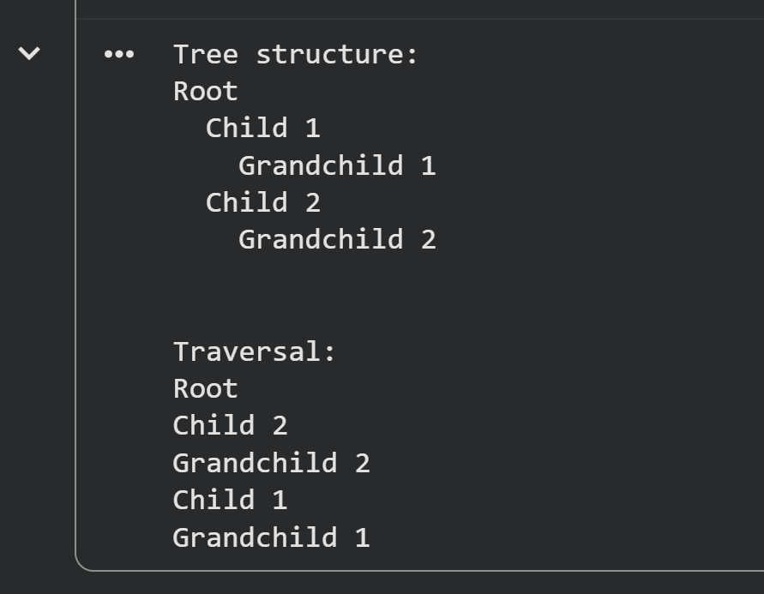
Figure 1 Output of the Program

- When would you prefer DFS over BFS and vice versa?
- DFS is preferred in solving puzzles or mazes as its backtracking process is suited in finding the best solution. BFS is efficient when finding the shortest path in unweighted graphs [1].

- What is the space complexity difference between DFS and BFS?
- Both DFS and BFS uses the same space complexity, O(V). In DFS, the space complexity depends on the maximum depth of recursion, while BFS depends on the maximum number of vertices in the queue for its space complexity [2].

- How does the traversal order differ between DFS and BFS?
- The traversal order differ between DFS and BFS as DFS explores connections as far as possible in each branch, while BFS visits all neighbors in the same depth first before proceeding deeper into the graph.

- When does DFS recursive fail compared to DFS iterative?
- Although DFS is easier to write it fails on deep graphs and can cause stack overflow. BFS on the other hand, has no risk of stack overflow and more memory-safe for large or deep graphs [3].
.

Conclusion
The program demonstrates how traversal works within a tree data structure, specifically utilizing the Depth-First Search (DFS) approach. By starting at the root node and prioritizing traversal through the leftmost child, the algorithm systematically explores each branch of the tree to its deepest level before backtracking. This process continues until all nodes have been visited. Overall, the program provides a clear and practical example of how tree traversal operates, emphasizing the structured and methodical nature of the Depth-First Search algorithm.

References
[1] “When to Use BFS vs DFS in Graph Problems: A Comprehensive Guide – AlgoCademy Blog,” Algocademy.com, 2025. https://algocademy.com/blog/when-to-use-bfs-vs-dfs-in-graph-problems-a-comprehensive-guide/ (accessed Oct. 25, 2025).
[2] T. Sauce, “Time Complexity and Space Complexity of DFS and BFS Algorithms,” Medium, Oct. 21, 2023. https://techsauce.medium.com/time-complexity-and-space-complexity-of-dfs-and-bfs-algorithms-671217e43d58
[3] Arlan N, “DFS Iterative vs Recursive: When to Use Each and Why It Matters - Lodely,” Lodely.com, 2025. https://www.lodely.com/blog/dfs-iterative-vs-recursive (accessed Oct. 25, 2025).

